REV. | Description |  |  |  |  |  | Date
00 | SPEC ISSUE (NEW MODEL)  ADP-420DR AAA |  |  |  |  |  | 09/26’23
01 | 102A-23B172  ADD ITEM 11-16(MECHANICAL)  16. 重量: 620g +/-5% |  |  |  |  |  | 11/17’23
02 | 102A-23B153  ADD MODEL: ADP-420DR AAB,ADP-420DR AAC |  |  |  |  |  | 11/20’23
03 | 102A-243139  1. ITEM 11.2 SHOCK TEST CONDITION UPDATE |  |  |  |  |  | 03/19’24
04 | 102A-244107  1. ITEM 16 重量變更由 "620g+/-5%" 變更為 "620g+/-15g" |  |  |  |  |  | 04/11’24
05 | 102A-244148  Add Model: ADP-420DR AA,ADP-420DR AAD,ADP-420DR AAE |  |  |  |  |  | 04/16’24
06 | 102A-244201  1. item 7.4 Efficiency  0A : <0.17W, 0.009A:35%, 0.01A:37.8%, 0.025A : 61.5%, 0.05A : 66.4%, 0.1A : 72.4%, 0.2A : 76.7%, 0.3A: 81.5%, 0.4A: 82%, 0.6A:82.5%, 1A:82%, 10A:89%, 20A:88%, 31A : 85.5%, 35A : 85.5% |  |  |  |  |  | 04/18’24
07 | 102A-244211  1. Item 4.3 Input current 6.0A to 5.5A. |  |  |  |  |  | 04/23’24
08 | 102A-245130  Add Model: ADP-420DR AB, ADP-420DR ABA, ADP-420DR ABB, ADP-420DR ABC |  |  |  |  |  | 05/14’24
 |  |  | 台達電子工業股份有限公司  DELTA ELECTRONICS, INC. |  |  | DESCRIPTION :  電氣規格 (Electrical Specification)
THESE DRAWINGS AND SPECIFICATIONS ARE THE PROPERTY OF DELTA  ELECTRONICS, INC. AND SHALL NOT BE REPRODUCED OR USED AS THE  BASIS FOR THE MANUFACTURE OR SELL OF APPARATUSES OR DEVICES  WITHOUT PERMISSION. |  |  |  |  |  | MODEL NO. :  ADP-420DR A SERIES
Date |  | Drawn |  | Design (EE) | Design (ME) | DOCUMENT NAME. :  ES-420DR A SERIES |  | REV.
05/14’24 |  | 蘇雲巧 |  | 王竹君 | 李昱緯 |  |  | 08
FRAME Name:DF-PSLA4V-2R01.DOC SHEET 1 OF 16

MODEL LIST: ADP-420DR AAA, ADP-420DR AAB, ADP-420DR AAC, ADP-420DR AAD, ADP-420DR AAE, ADP-420DR AA, ADP-420DR AB, ADP-420DR ABA, ADP-420DR ABB, ADP-420DR ABC

1.Scope

This specification applies to the switching regulator used for Class II type products.
2.Specification

Refer to the following
3.Applicable Standard
3-1. Safety specifications
International | IEC 62368-1:2018 (Third Edition)
International | *Include AC 100V
United States | UL 62368-1, 3rd Ed, 2019-12-13
Canada | CAN/CSA C22.2 No.62368-1-19, 3rd Ed
Europe | EN 62368-1:2020 (Third Edition) + A11:2020
Korea | K62368-1
China | CCC GB4943.1-2022 (Safety)

3-2. EMC
EMC | Item | Specifications and Test Conditions
EMI | Conduction  (雜音端子電壓) | VCCI-B, FCC Part15 B  EN55032, KS C 9832:2019, CISPR32, CISPR35
EMI | Radiation  (不要輻射) | VCCI-B, FCC Part15 B  EN55032, KS C 9832:2019, CISPR32, CISPR35
EMI | Harmonic  (電源高調坡) | EN 61000-3-2
EMI | Flicker  (電源閃爍) | EN 61000-3-3
EMS | Electrostatic Discharge  (靜電氣放電) | IEC61000-4-2  Test Probe: 150pF / 330 ohm  Air : ~ +/- 8kV  Contact : ~ +/-6kV  No function error, no latch off, no damage.
EMS | RS  (放射無線周波數磁界) | IEC61000-4-3  3V/m  AM modulation  1kHz 80%  80~10000MHz  Sweep rate: 1.5x10-3 decade/s  No function error, no latch off, no damage.
EMS | EFT/B  (快速暫態雜訊) | IEC61000-4-4  1KV  No function error, no latch off, no damage.
EMS | Surge  (雷擊) | IEC61000-4-5  Common : +/-4KV  Normal : +/-2KV  Phase + : 0ºC, 90ºC  Phase - : 180ºC, 270ºC  No function error, no latch off, no damage.
EMS | CS  (傳導性妨害) | EC61000-4-6  3V  AM modulation  1kHz 80％  0.15～80MHz  Sweep rate:1.5x10-3 decade/s  No function error, no latch off, no damage.
EMS | Immunity  (電源周波數磁界) | IEC61000-4-8  1A/m  x,y,z direction  No function error, no latch off, no damage.
EMS | AC dip  (電源電壓變動) | IEC61000-4-11  Above 95%, reduction,0.5 cycle No function error, no latch off, no damage.  (240Vac→12Vac) & (100Vac→5Vac) (Performance Criterion B)  30% reduction, 25 cycle  (240Vac → 168Vac) & (100Vac→ 70Vac) After the test, AC OFF then ON , then unit  should be able to start again and no function  error, no latch, no damage. (Performance  Criterion C)  Above 95%, reduction,250 cycle  (240Vac→ 12Vac)&(100Vac→5Vac) After thet test, AC OFF then ON , then unit should be able to start again and no function error, no latch off, no damage.(Performance Criterion C).

4. Input characteristics
 | Item | Condition |  | Specification
1 | Rated input voltage | - |  | 100 ~ 240 Vac
2 | Input voltage range | - |  | 85 ~ 276 Vac
3 | Input current | 12V/35A @ 100Vac |  | Less than 5.5A
4 | Rated input frequency | - |  | 50Hz / 60Hz
5 | Input frequency | - |  | 47 ~ 63 Hz
6 | Input inrush current | 85 ~ 276 Vac  Rated load  (Test with  3KV AC  source). | Ta= 25ºC  Cold start | Less than 140A
6 | Input inrush current | 85 ~ 276 Vac  Rated load  (Test with  3KV AC  source). | Ta= 40ºC  Repeat AC ON<=>OFF  12V 0A | Less than 180A/2msec 以下
Safety certification
100-127V~5.5A
200-240V~2.5A

5. Output characteristics
5-1. Output System:
5-2 Output Characteristics:
Below output capacitance (smallest capacity) should be satisfied
12V : 22uF (Ceramic capacitor)

Output | Output Voltage |  | Output Current |  |  | Ripple & Nioise (at rated load)
Output | Rated | Tolerance | Peak | Rated | Min. | Ta= -5~40ºC
12V | 12V | + 5%,- 4% | 90A/30msec | 35A | 0A | 150mVp-p,max

Output | OCP | OVP
12V | 90 ~ 112.5A | 15.6V,max

Power ON/OFF (Sequence and Timing)

Item | Condition | Specification
t_on | AC ON to 12V turn on time | output voltage can be regulated to 12V+5%, -4%  within 2S.
t_off | 12V output voltage from 100% to 10%. | 12V output voltage from 100% to 10%.
t_r | 0V to 12V rise time | 12V output voltage from 5% to 95% within 2~20msec.
t_dur 1 | Rate input  Load : 20A or less | Hold up time.  Output voltage should keep in range of rated voltage more than 30ms.
t_9V_keep | After then AC OFF ,12V during hold up time(t_dur 1). And then 12V output voltage is set to 9V.  When load is more than 200(mA).  When load is less than 1A in 9V output mode. PSU should keep output for 1s or more.  And if PSU is able to work normally by using internal remaining power, output should keep 9[V]（+5%/-4%） as long as  possible. .  Undershoot voltage should not be less  than 7[V] in output mode change situation between 12V mode and 9V mode. | 9V keeping time while 12V output voltage  is set to 9V output mode after AC OFF.
6. Other characteristics:
 |  | Item |  |  |  | Condition and Specification
1 |  | Over / Undershoot |  |  |  | Input range: 85 ~ 276 Vac  Output voltage should be within 10% of rated output voltage.
2 |  | Start with capacitive load |  |  |  | Input range: 85 ~ 276 Vac  Output should be in parallel with below capacitor :  12V : 12000uF  The unit should be able to start stably.
3 |  | Protective function |  |  |  | OCP |  | The 12V has been detected abnormal (12V OC/OV/OT/UV), 12V output should be shut down immediately.
 |  |  |  |  |  | OVP
 |  |  |  |  |  | OTP
Protection functional operation
(Signal and power output)
4 |  | Recovery from protection |  |  |  | Remove latch function after the AC OFF and within 3 minutes.
5 |  | Transient response |  |  |  | 12V | Input range: 85 ~ 276 Vac  [ 12V load change ]  Change range : 100～40[%], 90～30[%], 80～20[%], 70～10[%] of rated current  Change frequency : 10[Hz]～20[kHz].  Change rate : 1.0A/use |  |  | Output voltage should be requlated within 12V +5% -4%.
6. |  | Operating load range under natural air cooling |  |  |  | Load Condition:  7[A] or less under 25℃ / 4.5[A] or less under 40℃  Required Performance:  Must operate normally without OTP. 。  Not exceed parts temperature rating.  No abnormal interference to "end-product" operation.  If necessary, set appropriate temperature de-rating which decided  to satisfy the above criterion after mutual agreement.
7. Common specifications
 | Item |  |  |  | Condition |  |  |  | Specification
1 | Switching frequency |  |  |  | 100Vac input.  Rated load. |  |  |  | -
2 | Power factor |  |  |  | - |  |  |  | IEC61000-3-2.
3 | Life |  |  |  | Rated input voltage.  Ambient temperature, constant humidity. |  |  |  | 70,000Hr or more with thermal test BOX.  => 20,000Hr, 12V rated load  (FAN cooling).  => 50,000Hr, 12V 3A (w/o Fan).
4. | Efficiency |  | Light load  w/o Fan |  | Rated input voltage, load (0A). |  |  |  | 0.17W
4. |  |  |  |  | Rated input voltage, load (0.009A). |  |  |  | 35%
4. |  |  |  |  | Rated input voltage, load (0.010A). |  |  |  | 37.8%
4. |  |  |  |  | Rated input voltage, load (0.025A). |  |  |  | 61.5%
4. |  |  |  |  | Rated input voltage, load (0.05A). |  |  |  | 66.4%
4. |  |  |  |  | Rated input voltage, load (0.1A). |  |  |  | 72.4%
4. |  |  |  |  | Rated input voltage, load (0.2A). |  |  |  | 76.7%
4. |  |  |  |  | Rated input voltage, load (0.3A). |  |  |  | 81.5%
4. |  |  |  |  | Rated input voltage, load (0.4A). |  |  |  | 82%
4. |  |  |  |  | Rated input voltage, load (0.6A). |  |  |  | 82.5%
4. |  |  |  |  | Rated input voltage, load (1A). |  |  |  | 82%
4. |  |  | Normal load  With Fan |  | Rated input voltage, load (10A). |  |  |  | 89%
4. |  |  |  |  | Rated input voltage, load (20A). |  |  |  | 88%
4. |  |  |  |  | Rated input voltage, load (31A). |  |  |  | 85.5%
 |  |  |  |  | Rated input voltage, load (35A). |  |  |  | 85.5%
5 | Parts temperature |  |  |  | Rated input voltage.  Thermal test BOX.  Ta=40ºC |  |  |  | There is enough de-rating of temperature for all component.  No component over derating before OTP trigger.
6 | Hold up time  (瞬停保証時間) |  |  | t_dur1 | Rated input voltage  12V: 20A |  |  |  | 50Hz 1.5 cycle (=30ms).  Output voltage shall be satisfy electric characteristic.
7. | Leakage current |  |  |  | Normal temp and humidity  Rated input |  |  |  | 100uA or less
8 | Input discharge time |  |  |  | Input 121V or less, from AC power OFF to 37% rated. |  |  |  | 1 sec or less.
8 |  |  |  |  | Input 122V or more, from AC power OFF to 45V. |  |  |  | 1 sec or less.
9 | 入力片切test |  |  |  | AC ON→ Line OPEN→Line SHORT.  AC ON→Neutral OPEN→Neutral SHORT. |  |  |  | Same as AC ON→ AC OFF→ AC ON  Same as AC ON→ AC OFF→ AC ON
10 | Overvoltage apply test |  |  |  | 400Vac input / 2sec. |  |  |  | No safety hazard.
11 | Dielectric strength |  |  |  | Input between primary and secondary.  QA (sampling) : 3.0kVac 50/60Hz 60sec  Production line (all): 3.1kVac 50/60Hz 3sec |  |  |  | IEC60950-1 item 5.2  Sense current : 10mA or less.  Without damage to parts.
12 | Insulation resistance |  |  |  | 500 Vdc input between primary and secondary. |  |  |  | 10 Mohm or more.
13 | Insulation distance |  |  |  | - |  |  |  | Should be met the safety requirement and add external 0.5mm for SIE request.

8. Environmental
 | Item | Condition & Specification
1 | Operation temperature and humidity range | -5 ~ +40ºC  (humidity 20~90% Rh)
2 | Storage temperature and humidity range | -40 ~ +80ºC  (humidity 10~90% Rh)
3 | High humidity operation | Treatment : Storage for preprocessing before Hi temperature operation  +35ºC/90% Rh  Duration 8h  Electric characteristic shall be satisfied.
4 | Low temperature operation | Treatment : Storage for preprocessing before Low temperature operation  -5ºC  Duration 8hr  Electric characteristic shall be satisfied.
5 | Continuous operation under high temperature and high humidity | Condition of continuous operation  +40ºC/90% Rh  1000Hr operation.  Electric characteristic shall be satisfied.
6. | Continuous operation under room temperature and room humidity | Condition of continuous operation  +25ºC/30% Rh  Duration 48h  Electric characteristic shall be satisfied.
7. | Continuous operation under low temperature | Condition of continuous operation  -10ºC  Duration 48hr  Electric characteristic shall be satisfied.
8 | Continuous operation under low humidity | Condition of continuous operation  +20ºC/20% Rh  Duration 48hr  Electric characteristic shall be satisfied.
9 | Low temperature ON/OFF | Rated input voltage±10%.  Rated load.  Electric characteristic shall be satisfied.  Testing follow below temperature curve:  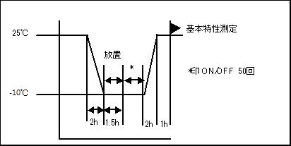
10 | High temperature and high humidity storage | After put the unit with max. storage +80ºC/90% Rh , duration 100Hr, then change the condition to ambient temperature & humidity 1Hr, and then test it.  Electric characteristic shall be satisfied.
11 | Low temperature storage | After put the unit with min. storage -40ºC, duration 100Hr,, then change the condition to ambient temperature 1Hr, and then test it.  Electric characteristic shall be satisfied.
12. | Humidity resistance | Treatment 1 : High temperature and high humidity storage  Temperature: 40±2℃  Humidity 90~95%  Duration: 48 hour  Treatment 2 : Standard atmospheric storage  Wipe moisture after treatment 1 , and then storage at the following condition  Temperature / Humidity : Room temperature and normal humidity.  Duration : 30min  Criteria after the above test :  Dielectric strength and insulation resistance must be satisfied.
13 | Thermal shock | Treatment : thermal shock (non-operation storage)  -40℃~80℃ / 100(Cyc)  Electric characteristic shall be satisfied and without distinct damage in appearance.  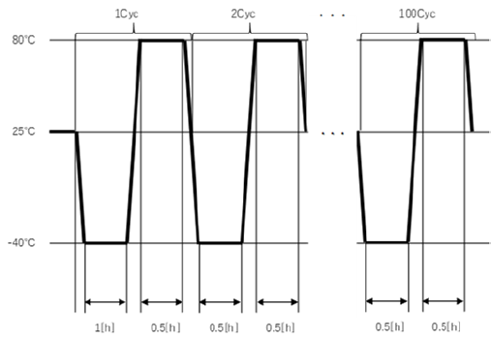
14 | Heat cycle | Treatment : thermal shock (non-operation storage)  -40℃~80℃ / 90 % RH  Electric characteristic shall be satisfied and without distinct damage in appearance.  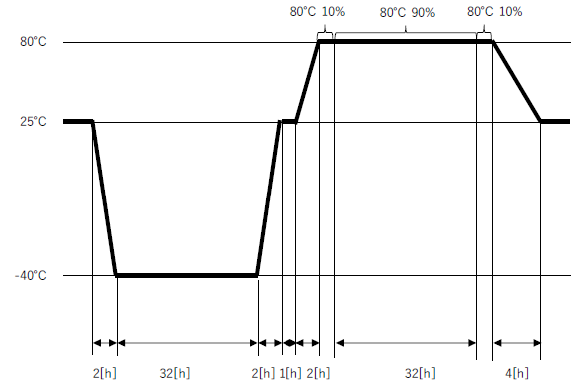

9. Other
 | Item | Condition & Specification
1 | Appearance | There is no adhesion of the foreign material and the dirty fingerprint. In addition, when producing it depends on the oil and the like which is used, there is no stench of the product.
2 | Adhesive | Chloroprene is designated as the main component, do not use the adhesive.
3 | Mass | --
4 | Noise | -

10. 耐久性能
 | Item | Condition & Specification
1 | Output open / short | 12V  Rated input voltage.  After output short 1sec, AC off (disable latch mode) then re-start as 1cycle, this 100 cycles after doing electric characteristic shall be satisfied.  (將輸出端子Short 一秒後, AC OFF (Latch解除) 再切入AC 以此為lcycle, 實行100 cycle後,  滿足電器特性 。)
2 | Power ON/OFF  (Secondary) | Rated input voltage +/-10%.  12V: Rated load (resistor)  Inside thermal test BOX,FAN cooling | The secondary ACDC_STBY control the ON/OFF shall be done 100,000 times.  (5sec/ON, 5sec/OFF)  Electric characteristic shall be satisfied.
3 | O/S test | Input voltage : 90V & 264V  Output load : Rated load.  Open & Short parts:  Transistor and IC: Combination between all terminals  Diode: Between A-K  Transformer & chock: Coil  Capacitance: Between terminals  When AC input turn on state, to do components open/short test. | No ignition or smoke or damage.
4 | Electrostatic Discharge | IEC61000-4-2  Rated input voltage.  Rated load.  Test probe: 150pF / 330 ohm.  Each 5 times.  Discharge location:  [Air]  . Any surface hand can touch except the air intake vent.  [Indirect]  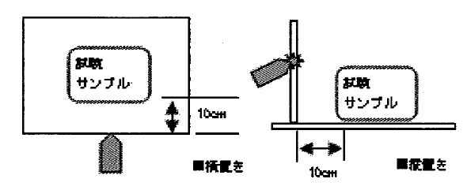  [Contact]  . Any metal hand can touch.  . power & signal (input/output). | Air :  +/- 12KV: no function error.  +/- 14KV: no latch off, no damage.  +/- 15KV: no quality accident.
4 | Electrostatic Discharge |  | Indirect :  +/- 8KV: no function error,  no latch off, no damage.  +/- 15KV: no quality accident.
4 | Electrostatic Discharge |  | Contact :  +/- 12KV: no function error,  no latch off, no damage.  +/- 15KV: no quality accident.
5 | Power noise | Rated input voltage, rated load.  Pulse width: 100ns/1000ns.  Noise voltage: +/-1kV. | No function error, no latch off, no damage.
6 | Lighting surge  雷擊 | Rated input voltage, rated load.  IEC1000-4-5 with CR box (13 ohm + 9uF)  Phase +: 0º, 90º.  Phase -: 180º, 270º.  Each 5 times.  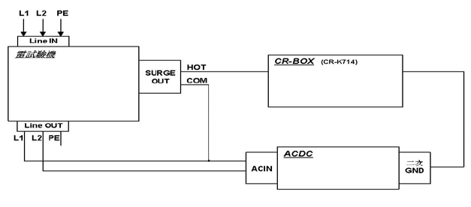 | L-N/N-L  +/- 6KV: no function error, no latch off,  no damage.  +/- 8KV: cam damage, no quality accident.  L-G/N-G  +/- 6KV: no function error, no latch off,  no damage.  +/- 8KV: cam damage, no quality accident.
11. MECHANICAL
Item |  | Judgement | Condition
1 | Vibration(1) | Electric characteristic shall be satisfied. And no remarkable abnormal occurrence on the appearance and construction. Parts and assembly with customer system must also be satisfied. | Non-operating/Random:  The entire frequency range from 7Hz(0.822 g² /Hz) to 30Hz(0.192 g² /Hz) and return to 7Hz(0.822 g² /Hz) shall be a transverse in 5 min. Three axis (X,Y,Z direction) shall be applied 20minutes acceleration: 23.5 m/s² (2.85Grms)
1 | Vibration  (2) | 判定基準：  1. 沒有異音（於測試過程or測試後, 不可有測試設備以外的異音）  2. 電気特性要満足。外観與構造沒有明顯異常 | 振動数：50Hz ～ 130Hz  加速度：2 [m/s^2]  振動Type：Sweep  方向＆時間：X,Y,Z 10分間
2 | Shock | Electric characteristic shall be satisfied. And no remarkable abnormal occurrence on the appearance and construction. Parts and assembly with customer system must also be satisfied. | 1.Non-operating/half-sine  Three axis (X,Y,Z direction) shall be  applied in both directions of mutually  perpendicular axis 1 times (a total of 6  times) for table a.  Sample : 1pcs  2.Non-operating/half-sine  A directions for a sample,  G & Duration value follow table b  Total sample : 6pcs  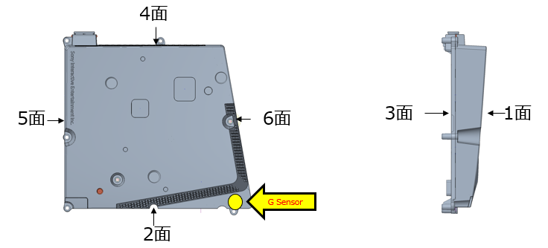
  累積保証
  落下面 | G | Duration
  1面 | 250 | 5
  2面 | 250 | 5
  3面 | 250 | 5
  4面 | 250 | 5
  5面 | 250 | 5
  6面 | 250 | 5
  G值換算 | G(產品) | G(平台) | Duration
  1面 | 250 | 266 | 5
  2面 | 250 | 234 | 5
  3面 | 250 | 244 | 5
  4面 | 250 | 225 | 5
  5面 | 250 | 190.5 | 5
  6面 | 250 | 246 | 5
  単面保証
  落下面 | G | Duration
  1面 | 500 | 2
  2面 | 500 | 2
  3面 | 700 | 2
  4面 | 500 | 2
  5面 | 500 | 2
  6面 | 500 | 2
  G值換算 | G(產品) | G(平台) | Duration
  1面 | 500 | 277 | 2
  2面 | 500 | 406 | 2
  3面 | 700 | 240 | 2
  4面 | 500 | 400 | 2
  5面 | 500 | 226 | 2
  6面 | 500 | 365 | 2
3 | Drop I | 1. No component broken..  2. No PWB copper pad peeling and broken  3. Hi-pot test pass with specific condition. ( AC 3300V/1min )  4. No soldering crack.  6. ATS function Pass. | 測試前,Case 請用螺絲鎖附在系統配合孔固定case  1.Drop TIMES: 5 times for every surface (six side),total 30 times  2. Test surface material : The concrete  3.Drop height: 10cm.
4 | Drop II | 1. No component broken..  2. No PWB copper pad peeling and broken  3. Hi-pot test pass with specific condition. ( AC 3300V/1min )  4. No soldering crack. .  5. ATS function Pass. | 測試前,Case 請用螺絲鎖附在系統配合孔固定case  1.Drop TIMES: 1 times for every surface (six side),total 6 times  2. Test surface material : The concrete  3.Drop height: 45cm.
12. Packing test :
12.1 Drop test condition:
<1>.Drop height:80.0CM
<2>.Impact surface: concrete floor
<3>.Drop times: 1 side (Bottom side),total 10 times
Criteria:
The sample has no electric characteristic issue and without
distinct damage in appearance.
12.2 Vibration test condition:
<1>.Wave: Random
<2>.Acceleration: 1.146Grms
<3>.Frequency: 5-200Hz
<4>.Duration:30min/side
<5>.Orientations: each axis total 3 times

Criteria:
The sample has no electric characteristic issue and without distinct damage in appearance.

12.3 Pallet Test
<1>. Container ( Truck ) Shipping test
- Test Distance: Manufacturing factory to ODM including return distance
- Test Item: Full packaged pallet
- Criteria: 1) PSU No Damage 2) Shipping material can’t have structural damage. Minor damage is accepted. 3) No any dust, ash or condensation water inside tray or PSU.
<2>. Sea Transportation Test
- Test Distance: Manufacturing factory to TW DEIC with sea transportation
- Test Item: Full packaged pallet
- Criteria: 1) PSU No Damage 2) Shipping material can’t have structural damage. Minor damage is accepted. 3) No any dust, ash or condensation water inside tray or PSU.

13. For safety
13.1 Altitude : 2000m
13.2 Thermal test setup

14. CN101
Pin_1 | Output (+) | 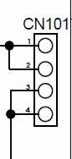
Pin_2 | Output (+)
Pin_3 | Output (-)
Pin_4 | Output (-)

15. CFM: Burn-in air flow 8.3CFM(流經電源內部)
16. 重量: 620g+/-15g
Product Ingress protection(IP) rating: Not requirement
Product Application: Game Consoles

